# My WordPress Plug-in

## Elementor

Elementor is a drag-and-drop website builder that adds extra customisable elements to your WordPress website.

Giving designers many more options for creating their websites and making mobile responsive editing for WordPress websites.

I will be using this plug-in to build my website dynamical and achieve the desired effect of my website



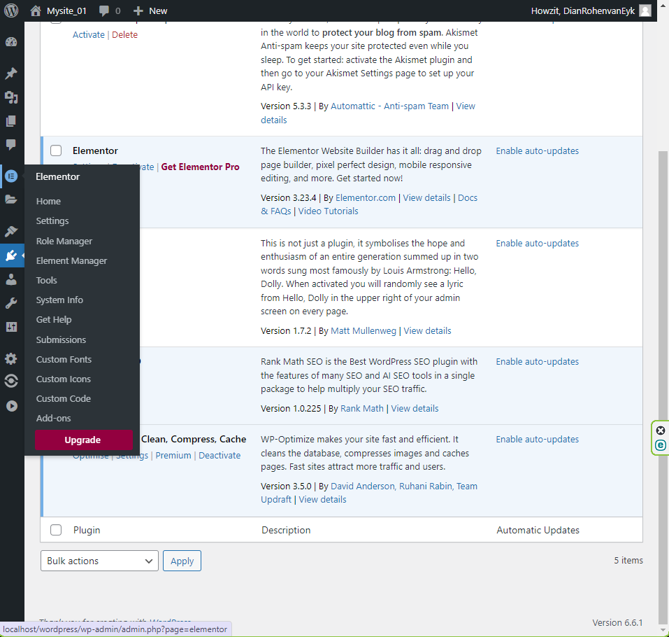

## WP-Optimise - Clean, Compress, Cache

WP-Optimize is a popular WordPress plugin designed to enhance website performance. It offers three main functions:

1. **Clean**: Optimizes your WordPress database by removing unnecessary data like post revisions, spam comments, and expired transients.
2. **Compress**: Reduces the size of images on your website, helping to speed up load times without sacrificing quality.
3. **Cache**: Stores a static version of your site to reduce the load on your server and improve page load speeds.

This will be used to help optimize my WordPress site to run efficiently for any user using the site to not cause database errors, especially when purchases occur



## Rank Math SEO

Rank Math SEO is a WordPress plugin designed to help users optimize their websites for search engines.

1. **On-Page SEO Analysis**: Offers real-time recommendations for optimizing posts and pages, including keyword usage, content length, and meta tags.
2. **404 Monitoring and Redirection**: Tracks 404 errors on your site and provides easy redirection options to prevent broken links and improve user experience.
3. **Integration with Google Search Console**: Connects your site to Google Search Console to access insights and analytics directly from your WordPress dashboard.

Rank Math Seo is going to be used to optimize my web pages for search engines and help attract traffic to my website to ensure healthy business and continued interest for years after launch.

